- Install and configure KServe
- install Knative Serving(CRDs + Core)
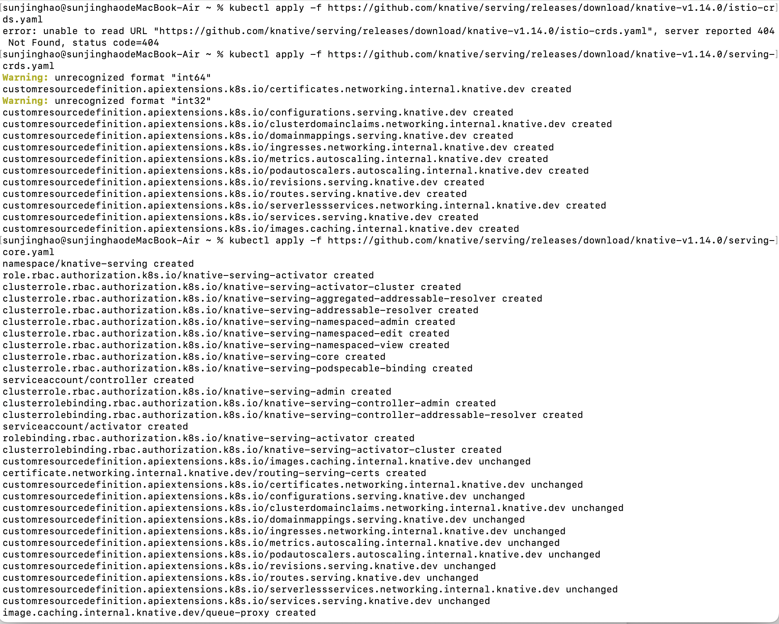
- install lstio(use istioctl)
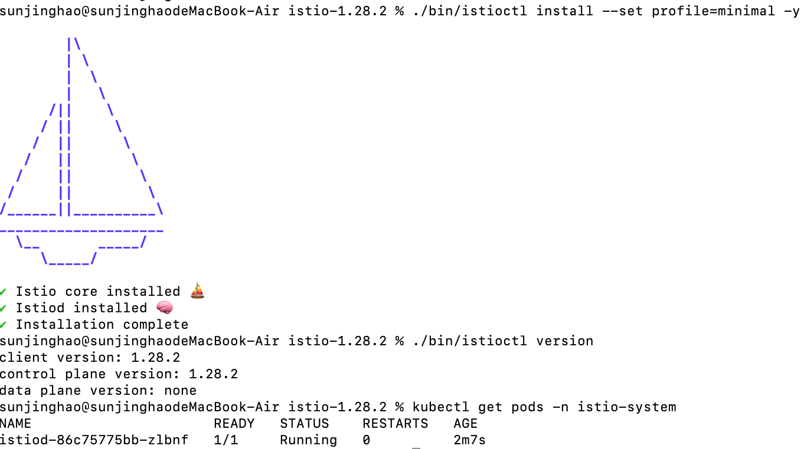

- install the istio network plugin of Knative
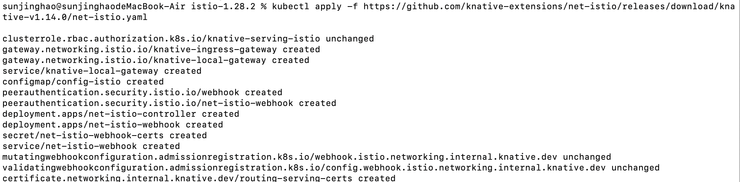

- check Knative pod
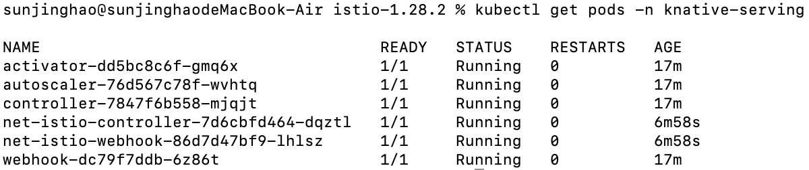
- check istio pod
- install Kserve

- Deploy prediction model
- Create iris-sklearn.yaml
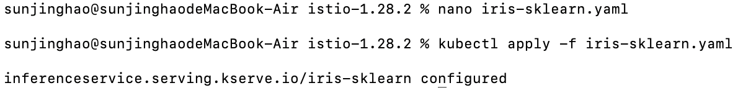
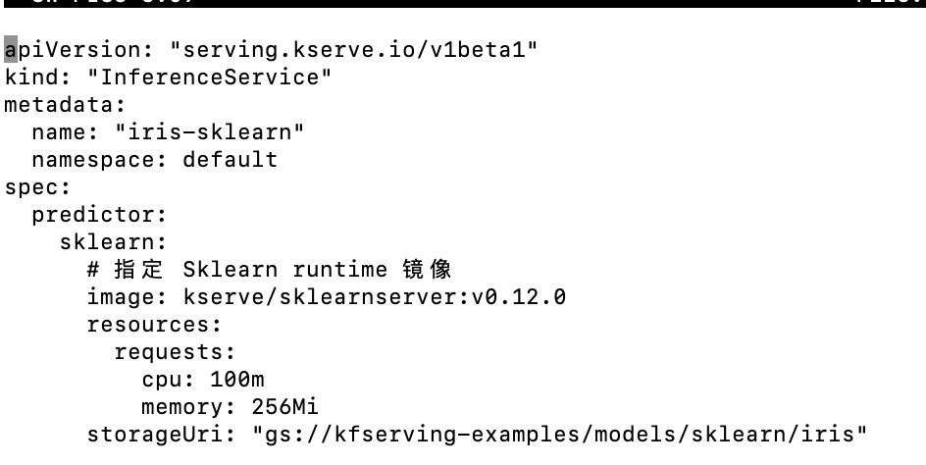

- Deploy inferenceService
- check the status of inferenceService

